**Test Case** **0014**

**System:** VirtuCardsClient & VirtuCardsHost

**Description:** Tests that the host can end the game with a winner and without a winner in Freeplay

**Severity:** 3

**Instructions**

**Test 1**

1. Start VirtuCardClient application
2. Click the button labeled “Sign In”
3. Enter “virtucards01@gmail.com” into the text input labeled “Enter email…”
4. Enter “Testing1” into the text input labeled “Enter password…”
5. Press the button labeled “Login”
6. A window should appear saying “Login Success”
7. Press the OK button that appears on that window
8. Start VirtuCardHost application
9. Repeat steps 2-7 but on the VirtuCardHost application
10. The checkbox “Allow Host to Join” should be checked on the host
11. Click the dropdown menu to view options
12. Select the Freeplay game mode
13. Press the Create Game button
14. In the VirtuCardClient application enter the 6-character room code found on the host’s screen into the field labeled “Enter Code…”
15. Press the Join Game button on the client
16. The client should be taken to a waiting screen and the username “Testing0001” should appear on the host.
17. Press the Start Game button on the host.
18. On the host screen host should click the “declare winner button”.

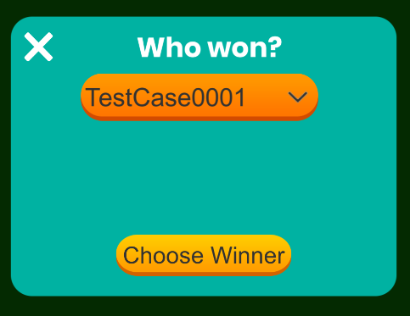

* This is what should be shown on the host screen

1. On the dropdown, select the name of the client in the room.
2. Click the Choose Winner button

**Expected Result:** The host screen should display the name of the winner and the client screen should be updated to say that they are the winner

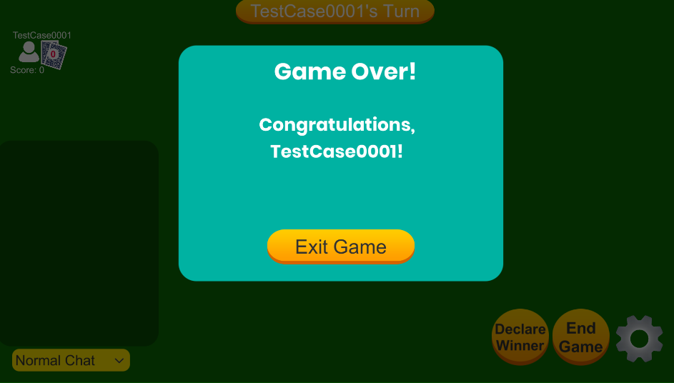

* This is what should be displayed on the host side

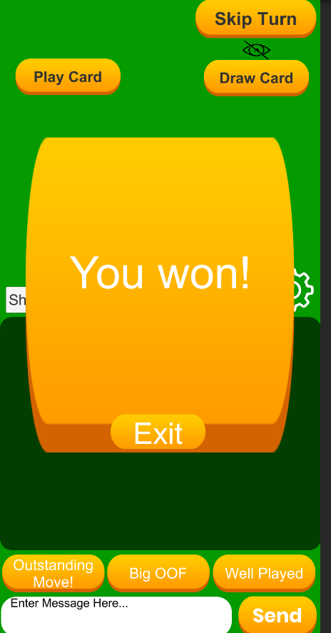

* This is what the client side should look like

1. On the host click the exit game button
2. On the client click the exit game button

**Expected Result:** The host should be back at the page where they can create a game and the client should be back at the page where they can join a new game

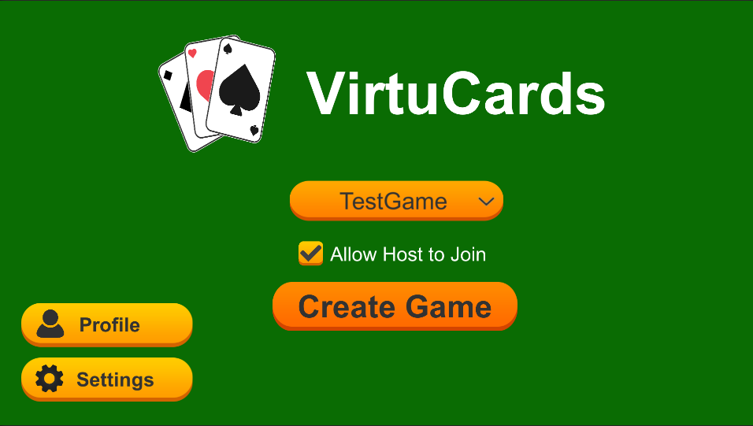

* This is the screen that the host should be taken back to

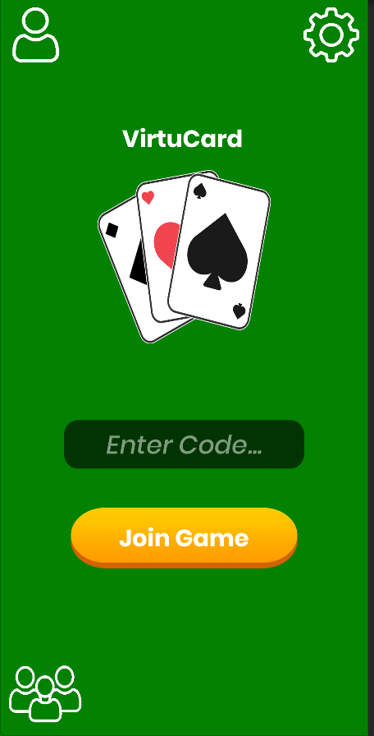

* This is the screen that the client should be taken back to

**Test 2**

1. Start VirtuCardClient application
2. Click the button labeled “Sign In”
3. Enter “virtucards01@gmail.com” into the text input labeled “Enter email…”
4. Enter “Testing1” into the text input labeled “Enter password…”
5. Press the button labeled “Login”
6. A window should appear saying “Login Success”
7. Press the OK button that appears on that window
8. Start VirtuCardHost application
9. Enter “2@2.com” into the text input labeled “Enter email…”
10. Enter “Testing12345” into the text input labeled “Enter password…”
11. Press the button labeled “Login”
12. A window should appear saying “Login Success”
13. Press the OK button that appears on that window
14. The checkbox “Allow Host to Join” should be checked on the host
15. Click the dropdown menu to view options
16. Select the Freeplay game mode
17. Press the Create Game button
18. In the VirtuCardClient application enter the 6-character room code found on the host’s screen into the field labeled “Enter Code…”
19. Press the Join Game button on the client
20. The client should be taken to a waiting screen and the username “Testing0001” should appear on the host.
21. Press the Start Game button on the host.
22. On the host screen host should click the “declare winner button”.
23. On the dropdown, select the name of the client in the room.



* This is what that panel should look like when navigating to it through the declare winner button

1. Click the Choose Winner button

**Expected Result:** The host screen should display the name of the winner and the client screen should be updated to say that they are the winner



* Once the host has declared a winner this is what their screen should look like



* This is what the client-side screen should look like when they have been declared as a winner

1. On the host click the exit game button
2. On the client click the exit game button

**Expected Result:** The host should be back at the page where they can create a game and the client should be back at the page where they can create a new game



* This is what the host screen should look like after they have clicked the exit game button



* This is what the client screen should look like after they have clicked the exit button and navigated back to the original screen to join a game

**Test 3**

1. Start VirtuCardClient application
2. Click the button labeled “Sign In”
3. Enter “virtucards01@gmail.com” into the text input labeled “Enter email…”
4. Enter “Testing1” into the text input labeled “Enter password…”
5. Press the button labeled “Login”
6. A window should appear saying “Login Success”
7. Press the OK button that appears on that window
8. Start VirtuCardHost application
9. Repeat steps 2-7 but on the VirtuCardHost application
10. The checkbox “Allow Host to Join” should be checked on the host
11. Click the dropdown menu to view options
12. Select the Freeplay game mode
13. Press the Create Game button
14. In the VirtuCardClient application enter the 6-character room code found on the host’s screen into the field labeled “Enter Code…”
15. Press the Join Game button on the client
16. The client should be taken to a waiting screen and the username “Testing0001” should appear on the host.
17. Press the Start Game button on the host.
18. On the host screen host should click the end game button.

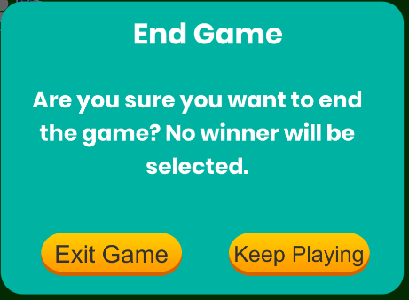

* When end game is clicked, this is the panel that should be displayed. It is meant to confirm whether the host wants to continue with this action

1. Click the exit game button

**Expected Result:** The host screen and the client screen should display a game over screen

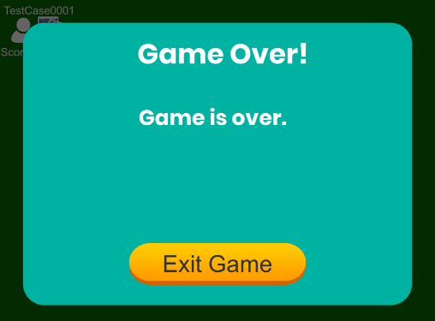

* On the host side this is what the game over screen looks like

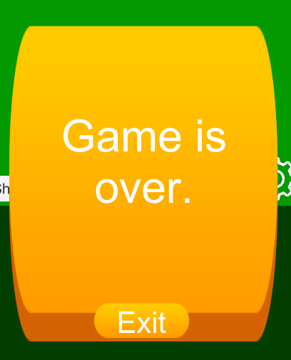

* On the client side this is what the game over screen looks like

1. On the host click the exit game button
2. On the client click the exit game button

**Expected Result:** The host should be back at the page where they can create a game and the host should be back at the page where they can create a new game



* This is what the host screen should look like after they have clicked the exit game button



* This is what the client screen should look like after they have clicked the exit button and navigated back to the original screen to join a game

**Test 4**

1. Start VirtuCardClient application
2. Click the button labeled “Sign In”
3. Enter “virtucards01@gmail.com” into the text input labeled “Enter email…”
4. Enter “Testing1” into the text input labeled “Enter password…”
5. Press the button labeled “Login”
6. A window should appear saying “Login Success”
7. Press the OK button that appears on that window
8. Start VirtuCardHost application
9. Enter “2@2.com” into the text input labeled “Enter email…”
10. Enter “Testing12345” into the text input labeled “Enter password…”
11. Press the button labeled “Login”
12. A window should appear saying “Login Success”
13. Press the OK button that appears on that window
14. The checkbox “Allow Host to Join” should be checked on the host
15. Click the dropdown menu to view options
16. Select the Freeplay game mode
17. Press the Create Game button
18. In the VirtuCardClient application enter the 6-character room code found on the host’s screen into the field labeled “Enter Code…”
19. Press the Join Game button on the client
20. The client should be taken to a waiting screen and the username “Testing0001” should appear on the host.
21. Press the Start Game button on the host.
22. On the host screen click the end game button



* When end game is clicked, this is the panel that should be displayed. It is meant to confirm whether the host wants to continue with this action

1. Click the exit game button

**Expected Result:** The host screen and the client screen should display a game over screen



* On the host side this is what the game over screen looks like



* On the client side this is what the game over screen looks like

1. On the host click the exit game button
2. On the client click the exit game button

**Expected Result:** The host should be back at the page where they can create a game and the host should be back at the page where they can create a new game



* This is what the host screen should look like after they have clicked the exit game button



* This is what the client screen should look like after they have clicked the exit button and navigated back to the original screen to join a game